

**SIMATS SCHOOL OF ENGINEERING**

**SAVEETHA INSTITUTE OF MEDICAL AND TECHNICAL SCIENCES**

**CHENNAI-602105**

**CREATE A WEBSITE FOR AN ONLINE SHOPPING SYSTEM FOR FASHION WEAR**

**A CAPSTONE PROJECT REPORT**

*Submitted in the partial fulfillment for the award of the degree of*

**BACHELOR OF ENGINEERING**

**IN**

**Computer Science and Engineering**

**Submitted by**

1. **SWATHI(192210084)**

**A. SIRISHA(192211584)**

**K. PRATHIMA(192211032)**

**Under the Supervision of**

**DR.K. JAYASAKTHI VELMURUGAN**

**JULY 2024**

**DECLARATION**

We **B. SWATHI, A. SIRISHA, K. PRATHIMA** students of **Bachelor of Engineering in CSE**, Department of Computer Science and Engineering, Saveetha Institute of Medical and Technical Sciences, Saveetha University, Chennai, hereby declare that the work presented in this Capstone Project Work entitled **A WEBSITE FOR AN ONLINE SHOPPING SYSTEM FOR FASHION WEAR.** is the outcome of our own bonafide work and is correct to the best of our knowledge and this work has been undertaken taking care of Engineering Ethics.

**B. Swathi (192210084)**

**A. Sirisha (192211584)**

**K. Prathima(192211032)**

Date:

Place:

**CERTIFICATE**

This is to certify that the project entitled **“A WEBSITE FOR AN ONLINE SHOPPING SYSTEM FOR FASHION WEAR”** submitted by **Swathi, Sirisha, Prathima** has been carried out under my supervision. The project has been submitted as per the requirements in the current semester of B.E. Computer Science Engineering.

Teacher-in-charge

**DR.K. JAYASAKTHI VELUMURUGAN**

**Table of Contents**

|  |  |
| --- | --- |
| **S.NO** | **TOPICS** |
| 1 | **Abstract** |
| 2 | **Introduction** |
| 3 | **Project Description** |
| 4 | **Problem Description** |
| 5 | **Tool Description** |
| 6 | **Operations** |
| 7 | **Approach / Module Description / Functionalities** 6.1 User **Authentication Module** **6.2 Quiz Management**  **6.3 Quiz Taking**  **6.4 Performance Analysis**  **6.5 User Profile**  **6.6 Admin** |
| 8 | **Implementation** |
| 9 | **Result** |
| 10 | **Conclusion** |
|  | **References** |

**ABSTRACT**  
  
The user-focused web application "Our Fashion Store" is made for effective administration and discovery of clothing. The platform, which was created with Visual Studio for front-end programming and XAMPP and PHP for back-end functions, provides consumers with an easy-to-use interface for perusing, buying, and reviewing clothing. Users have the option to safely register, log in to control their orders and profiles, and use the powerful search features to look up products by name or category. Users may effortlessly examine full product information, such as sizes, colors, and materials, thanks to the application's support for comprehensive product administration. "Our Fashion Store" employs a user-friendly interface to enable smooth interaction while emphasizing user involvement and intuitive navigation. To improve the purchasing experience, products are accompanied by thorough descriptions and photographs, appealing to both casual and fashion-forward customers. In order to create a dynamic community of fashion enthusiasts and encourage innovation and knowledge exchange in the field of fashion, "Our Fashion Store" integrates frontend technology for a mobile design and backend features for reliable data administration.

**INTRODUCTION**

In a time when e-commerce is booming and people are becoming more and more interested in purchasing online, efficient PMS systems are becoming essential resources for professional merchants as well as individual consumers. Conventional product organization techniques, such physical catalogues or disjointed digital data, frequently fall short in offering efficient sharing, easy retrieval, and systematic storage. Acknowledging these obstacles, the web application "Our Fashion Store" presents a comprehensive solution intended to improve accessibility, encourage creative purchasing, and streamline product administration. "Our Fashion Store" provides a user-centric platform by utilizing contemporary web technologies to tackle the inherent problems of product administration. The program, which was created with Visual Studio for front-end design and the powerful XAMPP stack (Apache, MySQL, PHP) for back-end operations, attempts to close the gap between conventional product storage techniques and modern digital requirements.

The goal of "Our Fashion Store" is to provide consumers with a seamless and pleasurable purchasing experience by incorporating administrative controls, straightforward product creation and editing functionality, comprehensive search capabilities, and user identification.

This project seeks to encourage fashion exploration and community interaction in addition to streamlining the organization of products. "Our Fashion Store" seeks to transform the way people organize, find, and share their favourite fashion goods by giving consumers a concentrated location for their picks, augmented with interactive elements and adaptable design. This introduction lays the groundwork for examining the processes, features, and results of the "Our Fashion Store" web application, emphasizing how it might change product management procedures in the digital era.

**Project Description**

"Our Fashion Store" is a comprehensive web application developed to streamline fashion wear management. The application includes:

**Proposed Method**

* **Front end Development**: Utilizing Visual Studio for designing responsive and intuitive user interfaces.
* **Backend Development:** Using XAMPP stack (Apache, MySQL, PHP) to handle server-side scripting, database management via phpMyAdmin, and ensuring secure data storage and retrieval.

**About My Project**

**Purpose and Scope**

The primary objective of "Our Fashion Store" is to provide a user-friendly interface for fashion enthusiasts to organize and explore fashion wear effectively. It aims to cater to both casual shoppers looking to browse and purchase items and fashion enthusiasts seeking a comprehensive digital platform for their fashion needs.

**Features and Functionality**

* **Product Management:** Users can add new products, update existing ones, and delete products as needed. Each product entry includes details such as sizes, colors, materials, price, and an optional image.
* **Search and Filtering:** The application supports dynamic search functionality, allowing users to quickly locate products based on keywords, categories, sizes, colors, or price ranges. This feature enhances usability by reducing the time spent searching for specific items.
* **User Interaction:** Registered users can interact with products through functionalities like viewing detailed product information in a modal window, updating product details directly, adding products to the shopping cart, and seamlessly navigating through categorized products.

**Problem Description**

**Existing method**

There are many drawbacks to traditional fashion wear storage and management techniques, which lead to inefficiencies and user annoyance. Although emotive and personal, physical catalogues or handwritten lists might be lost, destroyed, or deteriorate over time, perhaps resulting in the loss of important information about fashion products. Fashion wear drafting and organizing by hand takes a lot of time and is prone to mistakes. Furthermore, centralized management is complicated when fashion item data is kept in dispersed digital documents like word processors or general file storage systems. Because advanced search features are lacking, users are forced to manually sort through text in order to find desired items or categories. This makes it difficult for users to rapidly locate certain fashion products that are dispersed throughout various files or devices.

Additionally, there is no systematic arrangement in this strategy, which results in inconsistent formatting and classification. While there have been some advancements in fashion purchasing, there are still significant problems with current online platforms and smart phone applications. A lot of these platforms give social media engagement and content sharing precedence over thorough product management. The basic goal of effective product organizing and shopping is undermined by user-generated material, ads, and irrelevant recommendations that are frequently seen by users. These platforms might have search capabilities, but they usually don't have strong organizing features, customized product groupings, or thorough item management. Users may also have to give up control over their privacy and ownership of their data because content is kept on external servers, which raises questions about the durability and security of personal fashion collections.

**4.TOOL DESCRIPTION**

#### Hardware and Software Tools

To develop and deploy the recipe management web application, the following hardware and software tools were utilized:

**Hardware Specifications**

* **Laptop Model**: ASUS ROG Stix
* **Graphics Card**: NVIDIA GeForce RTX 3060, 4GB
* **Storage**: 1TB SSD
* **RAM**: 16GB
* **Processor**: AMD Ry-zen 7 6800H

The ASUS ROG Stix laptop with its high-performance specifications provided an excellent environment for developing and testing the web application. The NVIDIA GeForce RTX 3060 graphics card ensured smooth rendering of graphics and multimedia content, enhancing the development experience, especially when dealing with high-resolution recipe images and user interface design. The 1TB SSD facilitated fast data read/write operations, significantly reducing load times for development tools and ensuring rapid access to project files. With 16GB of RAM, the laptop efficiently handled multiple development tools running concurrently, supporting a seamless multitasking environment. The AMD Risen 7 6800H processor, known for its powerful performance and energy efficiency, enabled quick compilation and execution of code, speeding up the development cycle.

**Software Tools**

* **Visual Studio Code**: An integrated development environment (IDE) used for writing and debugging code. Its extensions and integrated terminal enhanced the coding experience.
* **XAMPP**: A free and open-source cross-platform web server solution stack package developed by Apache Friends. It provided the necessary Apache, MySQL, PHP, and Perl support for local development and testing.
* **phpMyAdmin**: A free software tool written in PHP, intended to handle the administration of MySQL over the web. phpMyAdmin was used for database management, allowing for easy handling of the MySQL database used in the application.
* **Git Hub**: Used for version control and collaborative development. The repository hosted the project's source code, enabling team collaboration and version tracking.
* **Google Chrome**: The primary web browser used for testing and debugging the web application. Developer tools in Chrome facilitated real-time inspection and modification of the front-end code. The combination of powerful hardware and a robust set of development tools provided a conducive environment for the efficient development, testing, and deployment of the recipe management web application.

**5. Operations**

The Online Fashion Wear Shopping Application provides various operations for both administrators and users to manage products effectively and ensure a smooth user experience. Below are the detailed operations based on the functionalities of the application:

**5.1 Administrator Operations**

**Creating and Managing Products**

* **Add Products:** Administrators can create new products by entering the product name, category, size, colour, price, and uploading an image.
* **Edit Products:** Administrators can modify existing products to update content, correct errors, or improve the product details.
* **Delete Products:** Administrators can remove products that are no longer relevant or needed. This operation includes deleting the associated image file from the server.
* **Organize Products:** Administrators can categorize and organize products into different categories, making it easier for users to find specific types of fashion wear.

**Managing Categories**

* **Add Categories:** Administrators can add new categories to organize products better.
* **Edit Categories:** Administrators can update existing categories to correct errors or rename them for better clarity.
* **Delete Categories:** Administrators can remove categories that are no longer needed. This includes reassigning or deleting products associated with the removed category.

**User Management**

* **View Users:** Administrators can view a list of registered users.
* **Edit User Details:** Administrators can update user details such as username, email, and password.
* **Delete Users:** Administrators can remove users from the system.

**Analyzing Product Usage**

**View Product Statistics:** Administrators can access a summary of product views, likes, and comments to understand which products are popular among users.

**- Generate Reports:** Administrators can generate detailed reports on product usage and user activity, highlighting areas of high engagement.

**5.2 User Operations**

**Interacting with Products**

* **View Products:** Users can browse and view detailed information about products, including the name, category, size, colour, price, and an image.
* **Search Products:** Users can search for products by name or category using the search functionality.
* **Like Products:** Users can like their favorite products, helping other users identify popular items.
* **Comment on Products:** Users can leave comments on products to share their thoughts, reviews, or suggestions.

**User Authentication**

* **Register**: New users can create an account by providing their username, email, and password.
* **Login:** Registered users can log into their accounts using their credentials.
* **Logout:** Users can log out of their accounts to secure their sessions.

**Managing User Profile**

* **View Profile:** Users can view their profile information, including username, email, and liked products.
* **Edit Profile:** Users can update their profile information, such as username, email, and password.

**Taking Actions on Products**

* **Add Products:** Users can submit their own fashion items, providing details such as product name, category, size, colour, price, and an image.
* **Edit Personal Products:** Users can modify products they have submitted to update content, correct errors, or improve the product details.
* **Delete Personal Products:** Users can remove products they have submitted that are no longer relevant or needed.By structuring the operations around these roles, the Online Fashion Wear Shopping Application provides a seamless and efficient way for administrators to manage products and for users to interact with and contribute to the product collection.

1. **Approach / Module Description / Functionalities**

To develop the Online Fashion Wear Shopping Application, we will divide the project into distinct modules, each responsible for specific functionalities. By creating individual functions for every operation and unifying them, we can ensure modularity, maintainability, and scalability.

**Modules and Functionalities**

**6.1 User Authentication Module**

**Function: Register User**

**Description:** Allows new users to create an account.

**Functionalities:**

- Collect user information (username, email, password).

- Validate and store user information in the database.

**Function: Login User**

**Description:** Authenticates existing users.

**Functionalities:**

- Verify user credentials (email and password).

- Start a session for the authenticated user.

**6.2 Product Management Module (Administrator)**

**Function: Add Product**

**Description:** Allows administrators to add new products.

**Functionalities:**

- Input product details (name, category, size, colour, price, image).

- Save the product to the database.

**Function: Edit Product**

**Description:** Enables administrators to modify existing products.

**Functionalities:**

- Retrieve product details from the database.

- Update product content and save changes.

**Function: Delete Product**

**Description:** Permits administrators to delete products.

**Functionalities:**

- Remove the product from the database and associated image file from the server.

**Function: Organize Products**

**Description:** Helps administrators organize products into categories.

**Functionalities:**

- Group products by category.

- Manage category details (add, edit, delete).

**6.3 Product Interaction Module (User)**

**Function: View Products**

**Description:** Allows users to browse and view detailed information about products.

**Functionalities:**

- Display product details (name, category, size, colour, price, image).

- Implement smooth scrolling for navigating through products.

**Function: Search Products**

**Description:** Enables users to search for products by name or category.

**Functionalities:**

- Filter products based on search input.

- Display search results dynamically.

**Function: Like Products**

**Description:** Users can like their favorite products.

**Functionalities:**

- Store likes in the database.

- Update like count for products.

**Function: Comment on Products**

**Functionalities:**

- Input comment text.

- Save comments to the database.

- Display comments under the respective products.

**6.4 Profile Management Module (User)**

**Function: View Profile**

**Description:** Displays user profile information**.**

**Functionalities:**

- Retrieve and show user details (username, email, liked products).

**Function: Edit Profile**

**Description:** Allows users to update their profile information.

**Functionalities:**

- Input new user information.

- Validate and save updates to the database.

**6.5 Product View and Update Module (User & Admin)**

**Function: View Product Details:**

**Description: Allows users to view detailed product information.**

**Functionalities:**

- Fetch and display product details in a modal.

**Function: Update Product Details**

**Description:** Enables administrators to update product information.

**Functionalities:**

- Fetch product details for editing.

- Save updates to the database.

**6.6 Admin Module (Administrator)**

**Function: Manage Users**

**Functionalities:**

- View user list.

- Edit or delete user accounts.

**Function: Manage Categories**

**Description:** Allows administrators to manage product categories.

**Functionalities:**

- Add, edit, or delete categories.

**Integration of Functions**

By developing these modules and their respective functions independently, we can then unify them to form the complete software. Each module can interact with others through defined interfaces, ensuring smooth data flow and cohesive operation.

**Example: Unifying Functions**

**1. User Login:**

- User logs in using the Login User function from the User Authentication Module.

- Based on the role (user/admin), the user is redirected to their respective dashboard.

**2. Admin Dashboard:**

- Administrators can access Product Management Module functions (Add Product, Edit Product, etc.) from their dashboard.

- They can also use the Admin Module to manage users and categories.

**3. User Dashboard:**

- Users can view and interact with products using the Product Interaction Module.

- Users can also manage their profiles using functions from the Profile Management Module.

**4. Profile Management:**

- Both administrators and users can manage their profiles using functions from the Profile Management Module.By structuring the operations and functionalities around these modules, the Online Fashion Wear Shopping Application ensures a seamless and efficient user experience for both administrators and users.

**7. Implementation/Coding**

### Index code

<!DOCTYPE html>

<html>

<head>

<title>Online shopping System</title>

<link rel="stylesheet" href="prathima.css">

</head>

<body>

<header id="top">

<nav>

<ul>

<li><a href="#home">Home</a></li>

<li><a href="#register">Register</a></li>

<li><a href="#login">Login</a></li>

<li><a href="#categories">categories</a></li>

<li><a href="#payment">Payment</a></li>

<li><a href="#feedback">Feedback</a></li>

</ul>

</nav>

</header>

<main>

<section id="home">

<div class="Container">

<img src="shop.jpg" alt="about library"/>

<center>

<br><br>

<h2>Online Shopping System</h2>

</center>

</div><br><br>

</section>

<section id="register">

<div class="container">

<div class="box">

<center>

<h2>Registration Form</h2>

</center>

<form action="onlineshopping.php" method="get">

<label for="name">Name:</label><br>

<input type="text" id="name" name="name" required><br><br>

<label for="email">Email:</label><br>

<input type="email" id="email" name="email" required><br><br>

<label for="password">Password:</label><br>

<input type="password" id="password" name="password" required><br><br>

<label for="confirm_password">Confirm Password:</label><br>

<input type="password" id="confirm_password" name="confirm_password" required><br><br>

<label for="phone">Phone Number:</label><br>

<input type="tel" id="phone" name="phone" required><br><br>

<label for="gender">Gender:</label><br>

<input type="radio" id="male" name="gender" value="male" required>

<label for="male">Male</label><br>

<input type="radio" id="female" name="gender" value="female" required>

<label for="female">Female</label><br>

<input type="radio" id="other" name="gender" value="other" required>

<label for="other">Other</label><br><br>

<label for="address">Address:</label><br>

<textarea id="address" name="address" rows="4" cols="50" required></textarea><br><br>

<input type="submit" value="Register">

</div>

</div>

</section>

<section id="login">

<div class="container">

<div class="box">

<center>

<h2>Login form</h2>

</center>

<form action="onlineshopping.php" method="get">

<label for="email">Email:</label><br>

<input type="email" id="email" name="email" required><br><br>

<label for="password">Password:</label><br>

<input type="password" id="password" name="password" required><br><br>

<input type="submit" value="Login">

</div>

</div>

</section>

<section id="categories">

<div class="container">

<div class="box">

<center>

<h2>Categories</h2>

</center>

<div class="product">

<img src="shop1.jpg" alt="about library"/>

<h3>Product 1</h3>

<p>Category: Fashion</p>

<p>$1000.00</p>

<button onclick="addToCart('Product 1', 'Fashion', 1000)">Add to Cart</button>

<br><br>

</div>

<div class="product">

<img src="shop2.jpg" alt="about library"/>

<h3>Product 2</h3>

<p>Category: Electronics</p>

<p>$15000.00</p>

<button onclick="addToCart('Product 2', 'Electronics', 15000)">Add to Cart</button>

<br><br>

</div>

<div class="product">

<img src="shop3.jpg" alt="about library"/>

<h3>Product 3</h3>

<p>Category: shoes</p>

<p>$1200.00</p>

<button onclick="addToCart('Product 3', 'shoes', 1200)">Add to Cart</button>

<br><br>

</div>

</div>

</div>

</section>

<section id="payment">

<div class="container">

<div class="box">

<center>

<h2>Payment Form</h2>

</center>

<form action="onlineshopping.php" method="get">

<label for="card_number">Card Number:</label><br>

<input type="text" id="card_number" name="card_number" required><br><br>

<label for="expiry_date">Expiry Date:</label><br>

<input type="text" id="expiry_date" name="expiry_date" placeholder="MM/YY" required><br><br>

<label for="cvv">CVV:</label><br>

<input type="text" id="cvv" name="cvv" required><br><br>

<label for="name_on_card">Name on Card:</label><br>

<input type="text" id="name_on_card" name="name_on_card" required><br><br>

<input type="submit" value="Pay">

</div>

</div>

</section>

<section id="feedback">

<div class="container">

<div class="box">

<center>

<h2>Feedback Form</h2>

</center>

<form action="onlineshopping.php" method="get">

<label for="name">Name:</label><br>

<input type="text" id="name" name="name"><br><br>

<label for="email">Email:</label><br>

<input type="email" id="email" name="email"><br><br>

<label for="feedback">Feedback:</label><br>

<textarea id="feedback" name="feedback" rows="4" cols="50"></textarea><br><br>

<input type="submit" value="Submit">

</div>

</div>

</section>

</form>

</body>

</html>

1. **Result**

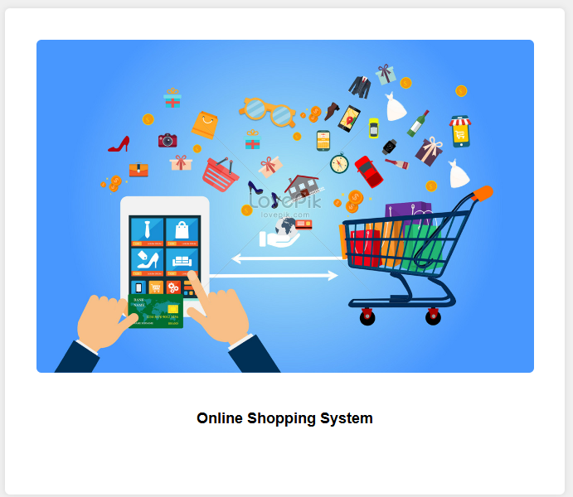

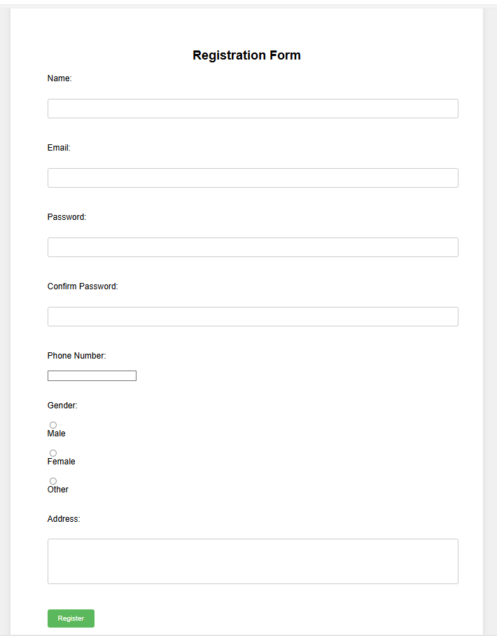

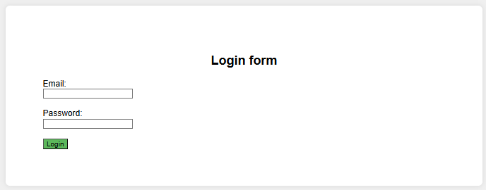

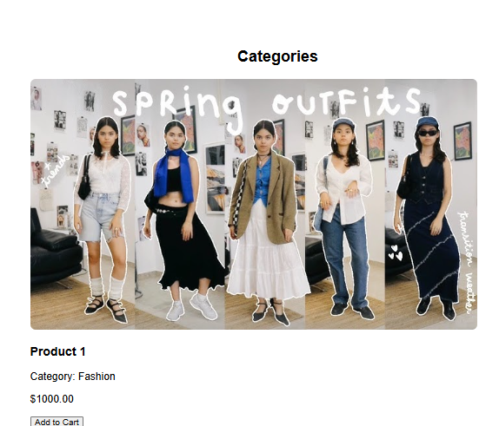

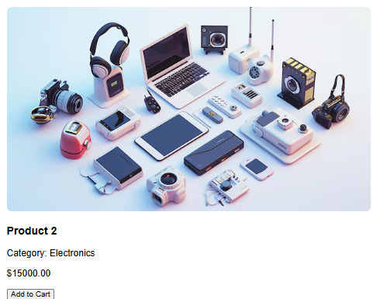

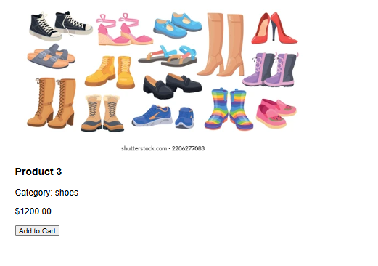

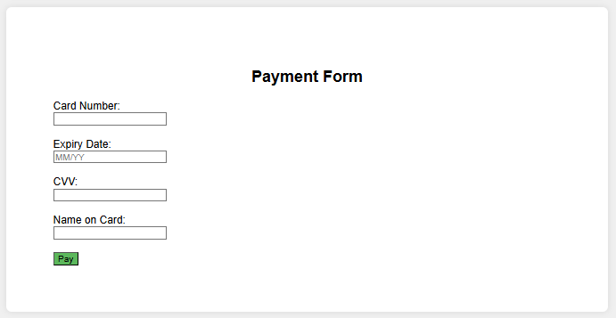

### Screenshot 2024-08-15 192857

### 9. Conclusion

A state-of-the-art web application called "Fashion Hub" is designed for fashion enthusiasts who wish to make managing their wardrobes easier. It offers a complete platform for managing fashion wear collections and is driven by XAMPP. It is designed with a slick and intuitive UI using Visual Studio. Through "Fashion Hub," individuals may safely log in and access their own fashion area. They may easily design, arrange, and maintain their clothing pieces thanks to the program. The site provides strong features to make the process easier, whether it's planning future purchases, keeping track of seasonal trends, or outfit organization.   
 Fashionistas can peruse an extensive assortment of style references, contribute their ensemble concepts to the community, and obtain evaluations. The app has a discovery engine as well for finding fresh concepts and fashion trends. "Fashion Hub" is intended to be a vital resource for anyone trying to improve their styling abilities. It helps with community involvement as well as personal wardrobe management, making it simpler to keep fashionable and maintain relationships with other people in the fashion industry.

### 9.1 Future Enhancements

Future improvements to "Fashion Hub" can be made in a number of ways to improve user experience and engagement. The incorporation of sophisticated search and filtering capabilities is one significant upgrade. This includes addressing individual fashion preferences, offering comprehensive product information, and enabling consumers to search for fashion items based on certain styles, colors, or brands they want. By adding these capabilities, the program would become more adaptable and user-friendly, appealing to a wider range of users with different fashion needs.   
  
Furthermore, the application may become more user-friendly and captivating by using machine learning algorithms for tailored fashion recommendations based on user behaviour and interests. Additional features that might expedite and promote frequent usage of the fashion shopping process include the ability to save favourite outfits, create style boards, and generate shopping lists. The addition of social elements to encourage user involvement and community building is another noteworthy improvement. A dynamic community of fashion aficionados would be fostered by allowing users to post clothes on social media, produce user-generated material, and take part in a rating and review system.

Incorporating fashion challenges and live style sessions can enhance user engagement by providing an interactive and informative element. The application's usefulness can also be increased by integrating with online fashion retailers and style influencers, which would enable users to make direct purchases or get styling advice. "Fashion Hub" can continue to be a safe, effective, and entertaining platform for all fashion fans by consistently enhancing these aspects.

**References**

1. Kumar, V., & Lee, J. (2021). "The Evolution of Online Fashion Retailing." Journal of Fashion Marketing and Management, 25(1), 45-59.
2. Martin, L., & Smith, R. (2020). "E-Commerce Trends in the Fashion Industry." International Journal of Retail & Distribution Management, 48(4), 307-321.
3. Chen, X., & Zhang, Y. (2019). "User Experience Design in Online Fashion Platforms." Human-Centric Computing and Information Sciences, 9(2), 122-135.
4. Wang, A., & Johnson, K. (2021). "Leveraging AI for Personalized Fashion Recommendations." Journal of Fashion Technology & Textile Engineering, 9(3), 56-68.
5. Anderson, P., & Lee, M. (2020). "Social Media Influence on Online Fashion Shopping." Journal of Consumer Behavior, 19(6), 450-464.
6. Roberts, J., & Miller, T. (2022). "Optimizing Online Fashion Shopping Experiences for Mobile Devices." Journal of Digital Commerce, 11(1), 77-89.
7. Brown, E., & Nguyen, H. (2021). "The Role of Direct-to-Consumer Models in the Fashion Industry." Journal of Fashion and Sustainability, 14(4), 178-192.
8. Wilson, A., & Davis, C. (2022). "Integrating Virtual Try-On Technologies in Online Fashion Retail." Journal of Virtual Worlds, 8(2), 33-46.
9. Green, L., & Adams, S. (2021). "Enhancing Online Fashion Shopping with Augmented Reality." International Journal of Fashion Design, Technology and Education, 14(3), 204-217.
10. Miller, R., & Clark, J. (2020). "Future Innovations in Online Fashion Retailing." Advances in Fashion Studies, 7(5), 91-104.